1.rectangle-area&perimeter(private data member):

#include<iostream>

using namespace std;

class rectangle{

private:

double l,b;

public:

void area(double ll,double bb){

l=ll;

b=bb;

double c=l\*b;

cout<<"area: "<<c<<endl;

}

void perimeter(double ll,double bb){

l=ll;

b=bb;

double c=2\*(l\*b);

cout<<"perimeter : "<<c;

}

};

int main(){

double x,y;

cout<<"enter the lenght and breadth:";

cin>>x>>y;

rectangle R;

R.area(x,y);

R.perimeter(x,y);

}

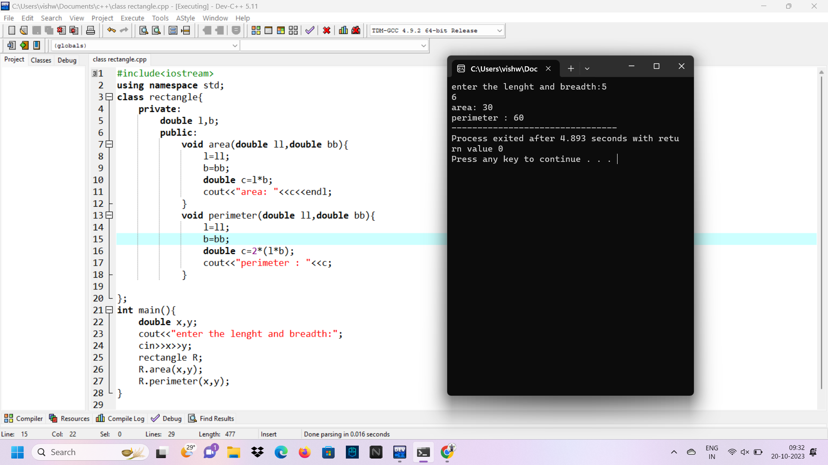

2.two constructor piggy bank:

using namespace std;

#include<iostream>

class piggybank

{

public:

int amount;

piggybank()

{

amount = 50;

}

piggybank(int a)

{

amount = 50 + a;

}

void display()

{

cout<<amount;

}

};

int main()

{

piggybank D1;

int amt;

cout<<"Enter amount to deposit"<<endl;

cin>>amt;

cout<<"\nInitial Amount in the Bank Rs: "<<D1.amount<<endl;

piggybank D2(amt);

cout<<"\nAmount in the Bank after deposit the amount is Rs: "<<D2.amount;

}

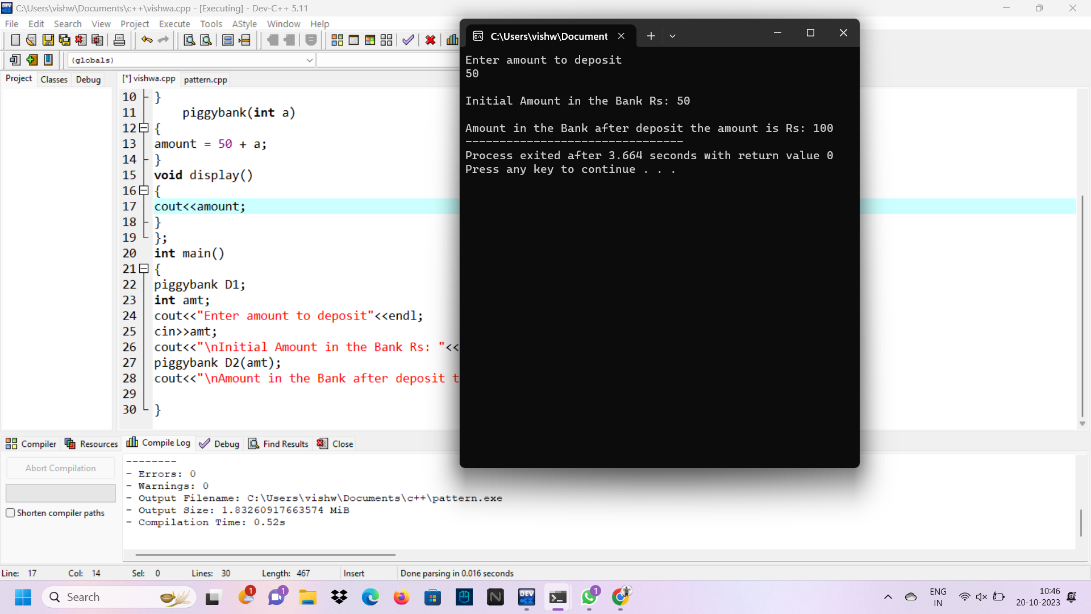

3.pattern:

|

|||

|||||

|||||||

#include <iostream>

using namespace std;

int main() {

int i,j, rows,k;

cout <<"Enter number of rows: ";

cin >> rows;

for( i = 1, k = 0; i <= rows; ++i, k = 0) {

for(j = 1; j <= rows-i; ++j) {

cout <<" ";

}

while(k != 2\*i-1) {

cout << "| ";

++k;

}

cout << endl;

}

return 0;

}

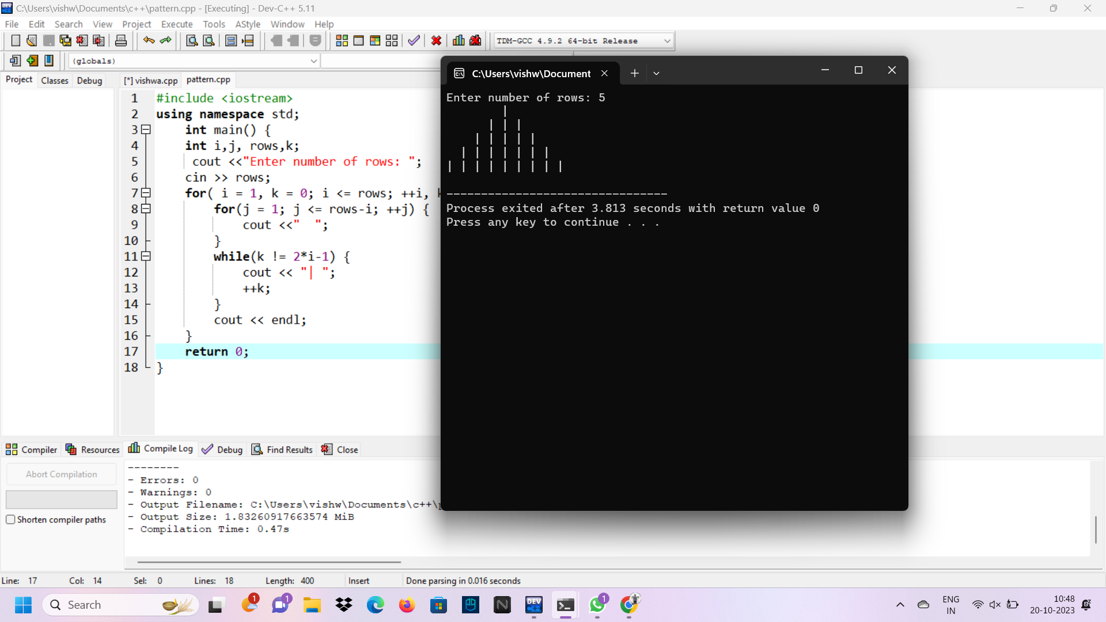

4.single inheritance:

#include<iostream>

using namespace std;

class vehicle{

public:

char make[100];

char model[100];

int year;

void function(){

cout<<"enter the make: ";

cin>>make;

cout<<"enter the model: ";

cin>>model;

cout<<"enter the year: ";

cin>>year;

}

};

class car: public vehicle{

public:

char color[100];

int seatings;

void function1(){

cout<<"enter the color: ";

cin>>color;

cout<<"enter the seatings: ";

cin>>seatings;

}

void display(){

cout<<"MAKE: "<<make<<endl;

cout<<"MODEL: "<<model<<endl;

cout<<"YEAR: "<<year<<endl;

cout<<"COLOR: "<<color<<endl;

cout<<"seatings: "<<seatings;

}

};

int main(){

car c;

c.function();

c.function1();

c.display();

}

